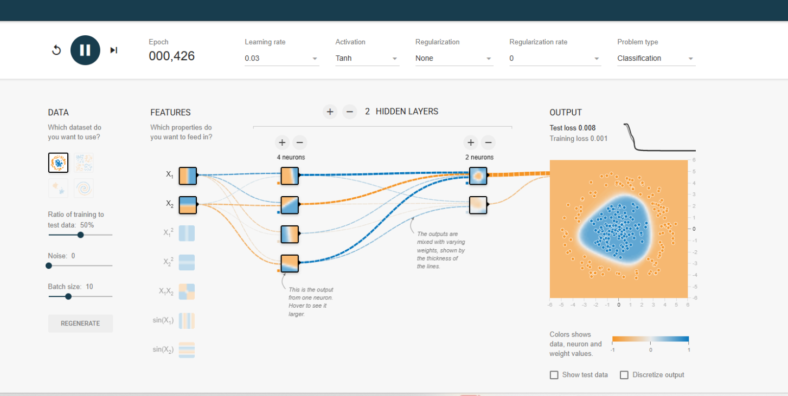
TensorFlow Playground, which is a visual tool to understand how neural networks learn. Let's break down how to read and interpret the output for classification:

🔍 You're doing a classification task (circle dataset)
🟠 What You See:
- Orange vs Blue background = predicted class regions
- White/black bordered circles = training or test data points
- Color inside the circle = predicted class
- Border color = actual label

📊 Key Areas to Interpret:
✅ 1. OUTPUT REGION MAP (Bottom Right):
- Blue area: Predicted Class 1 (positive class)
- Orange area: Predicted Class 0 (negative class)
- The shape of the boundary shows how well the model separates classes.
- A smooth, simple boundary = good generalization.
- Wiggly, overly complex boundary = overfitting.
✅ 2. TEST LOSS / TRAINING LOSS (Top Right):
- Training Loss: Error on training data.
- Test Loss: Error on test data.
- A low training loss + low test loss (like yours: 0.001 / 0.008) indicates:
✅ The model learned well
✅ No overfitting
✅ Good generalization
✅ 3. NETWORK CONNECTIONS (Center):
- Lines show weights between layers.
- Thicker lines = stronger influence.
- Color of line = weight sign (blue = positive, orange = negative).
- Neurons show activation patterns and learned features.
✅ 4. EPOCHS (Top Center):
- How many times the model has seen the full training dataset.
- You’re at 426 epochs, which is a good number to stabilize learning.

⚠️ Use This to Experiment:
Try changing:
- Regularization type and rate: Observe how the decision boundary simplifies.
- Noise: Add noise to test robustness.
- Hidden layers and neurons: See impact on overfitting/generalization.
- Learning rate: Too high may cause unstable training.

✅ Summary:
- Model is well-trained: low test and training loss
- Boundary nicely fits the circle-shaped class
- No overfitting observed (loss gap is minimal)
- No regularization applied yet, so it's purely learning from data

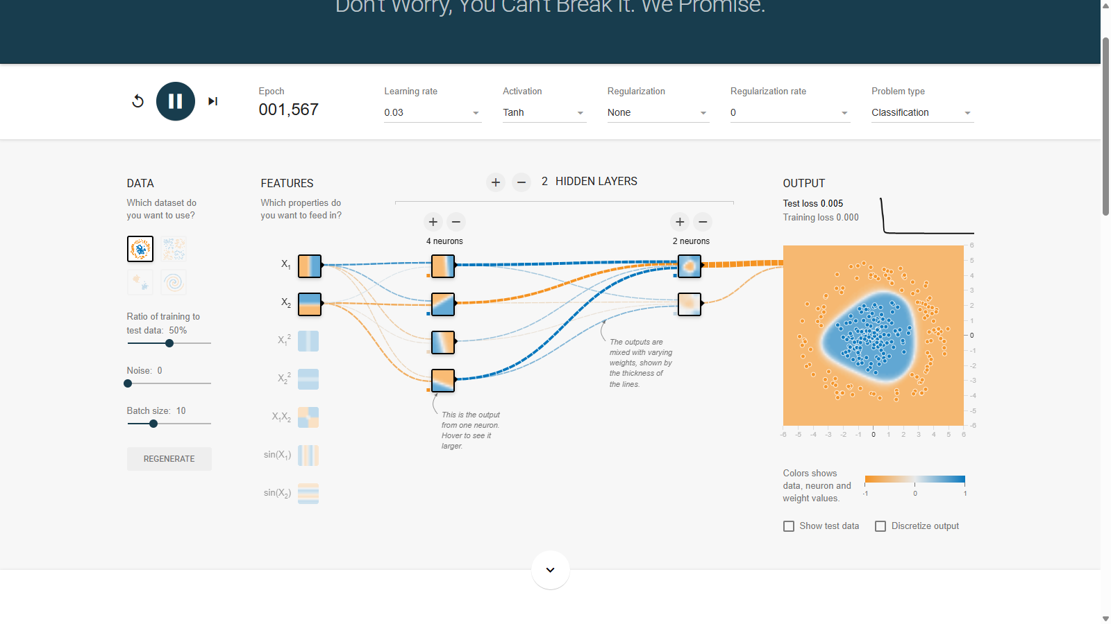
✅ Final Expected Result (for Classification on Circle Dataset):
In the setup:
- Problem Type: Classification
- Dataset: Circular — points inside the circle = Class 1 (blue), points outside = Class 0 (orange)
- Goal: Train a model to classify points correctly (learn the circular boundary)

🟢 What You're Seeing:
- Orange region: Model predicts class 0 (outside circle)
- Blue region: Model predicts class 1 (inside circle)
- Circles with white/black borders: Data points
  - Border = actual class
  - Fill color = predicted class

Current result shows:
- Very clear boundary between the blue and orange zones
- Almost all points are in their correct region
- Test loss = 0.005, Training loss = 0.000 → excellent fit without overfitting
- Prediction boundary matches the true circular shape of the data

🎯 So, the Final Expected Result is:
- A smooth circular boundary between classes.
- Low test and training loss (which you have).
- No major misclassified points.
- Model generalizes well (confirmed by the small test loss).
You're already seeing the best possible outcome:
✅ Good generalization
✅ Accurate classification
✅ Clean decision boundary
✅ No regularization needed in this case due to low complexity

